This week you will be given an opportunity to log on to a temporary MongoDB server from the lab machines.  To gain access to the server, run MongoChef. This is available from the desktop on the lab machines. C:\Users\patricia.obyrne\AppData\Local\Skitch\Screenshot_110817_100512_AM.jpg

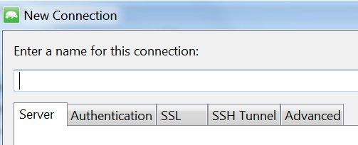Create a new connection. You will need to change two tabs; the server tab and the authentication tab.

In the server tab, change the server from localhost to 147.252.30.5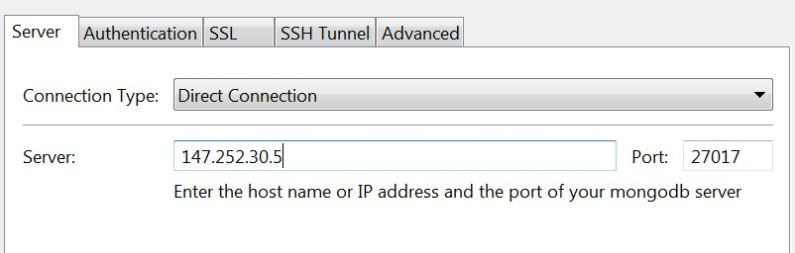

In the Authentication tab, change the username to your username, the password to your student number – lower case!!! And the database name to your username. The following would be Alan Turing’s: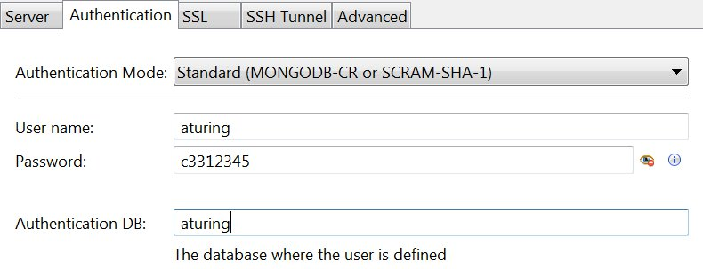

Your username is your first initial followed by your last name (e.g. Alan Turing's is aturing).  Your dbname is the same as your username and your pwd is your student number in lower case.  Everything is in lower case.

When you connect to your database, the connection will show up in the left sidebar of MongoChef. Right click on it and open Intellishell.

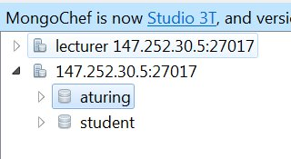

Tasks for this week:

1. Connect to your database as shown above. Run the queries from the ‘Using MongoDB’ presentation.
2. Switch to your own database by entering use <dbname> ﻿﻿﻿﻿﻿﻿﻿﻿﻿﻿
   1. E.g. use aturing
3. Start a collection (you may pick your own idea, or use the createcity.js script in webcourses) and insert documents into it as shown in the lecture.
4. Run queries on the data.

Today’s lab is not marked.

**FOR NEXT WEEK YOU MUST SHOW A MONGODB INSTANCE ON YOUR OWN MACHINE. There are instructions in the tutorial on the left sidebar in your webcourses module, labelled MongoDB.**